`

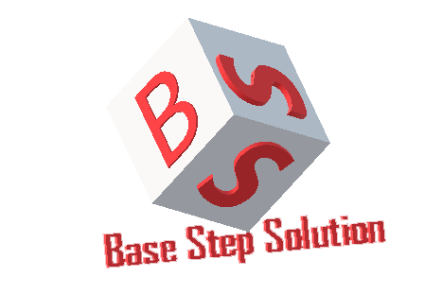

Software Architect Process Architectural Process

Van Lang Admissions

# Revision Table

|  |  |  |  |
| --- | --- | --- | --- |
| **Author** | **Date** | **Reason for changes** | **Version** |
|  |  |  |  |
|  |  |  |  |
|  |  |  |  |

Table of Contents

Revision Table 1

1. INTRODUCTION 3

1.1. Purpose 3

1.2. Audience 3

2. Process 4

2.1. Process flow 4

2.2. Activities 4

2.3. Roles and Responsibility 5

3. TOOLS AND METHODS 5

# INTRODUCTION

## Purpose

## Audience

The intended audience of the AR Plan is

|  |  |
| --- | --- |
| **Intended Audience** | **Description** |
|  |  |
|  |  |

# Process

## Process flow

## Activities

|  |  |  |  |
| --- | --- | --- | --- |
| **Stage** | **Description** | **Activities** | **General output** |
|  |  |  |  |
|  |  |  |  |
|  |  |  |  |
|  |  |  |  |
|  |  |  |  |

## Roles and Responsibility

|  |  |  |
| --- | --- | --- |
| **No** | **Role** | **Responsibility** |
|  |  |  |
|  |  |  |
|  |  |  |

1. TOOLS AND METHODS

|  |  |  |
| --- | --- | --- |
| **No** | **Tools and methods** | **Description** |
|  |  |  |
|  |  |  |